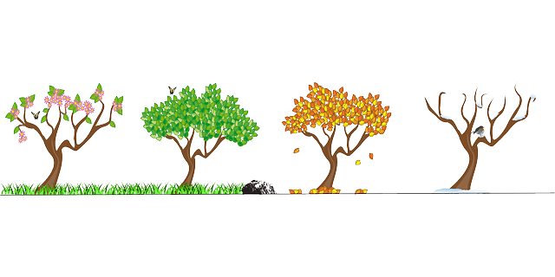
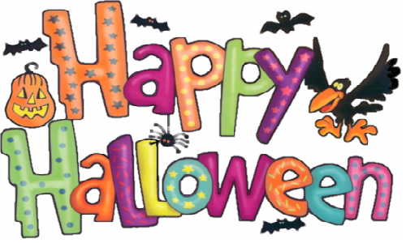
Bumblebee Newsletter
October 2020

Dear Parents,
Our first month of school has been great! The children are adjusting well to their new classroom and schedule. It has been a smooth transition and I want to thank you for all your help getting the school year off to a great start.
The theme for October is seasons, harvest and Halloween. We will be discussing the changes in seasons and how they affect animals, plants and weather patterns. We will also be highlighting activities that take place during each season, especially those taking place during the fall.
This year our Halloween Party will be held on Friday, October 30th from 8:30-11:00a.m. Children who do not usually come to school on Friday are invited to come and participate in the morning festivities. We encourage children to dress in their costumes! Please remember to bring a change of clothes for afterwards as well as a bag for your child’s costume. We ask that all make-up and accessories for their costumes be left at home and that all costume parts be labeled with your child’s name to avoid confusion. Weather permitting- we will have an all school costume parade at 8:45am. Parents are welcome to stay and line the fence on the southeast corner of the field to watch. If we are unable to be outside, we will conduct our parade in our classrooms. We will video and share the parade with you on our Facebook page. You are also invited to contribute treats and goodies to our parties. We will send you a link to Sign-Up Genius with opportunities to contribute to your child’s classroom party. Thank you in advance for your support and we will keep our fingers crossed for warm and dry weather.
Bumblebee Parent -Teacher Conferences will be held Thursday, October 22nd. These conferences can be in-person if you are comfortable coming in and meeting with me (with masks) at the school. If you prefer, you can sign up for a conference time and we can conduct your child’s conference over Zoom. More information and sign-ups will be available as conference times approach. I look forward to meeting with all of you to discuss your children.
Fall is here and winter is on the way! We will be going outside everyday, weather permitting. Please remember to send appropriate clothing labeled with your child’s name on days when the weather is a little cooler. On snowy days, we may be heading outside to play some winter games. Please remember to send snow boots, gloves and a hat for these days. We are also requesting that you send your child with a separate pair of shoes, wet snow boots will be put into a bin to dry. You are welcome to send a pair of labeled boots that can be left in our room for the season.
***Please send an extra mask with your child to leave at school in their cubby in case your child’s mask becomes dirty or wet. ***

Thank you again for all the support you have given me for the start of our school year!
Sincerely,
Mrs. Eaton

